ISTE NETS-A Standards Paper #5
Standard #5: Digital Citizenship
Alexe Miles and Sharon Thornell
EDIT 760: Instructional Technology Leadership

The ISTE NETS-A Standard 5 primarily deals with the responsibility of educational leaders to model and ensure understanding of social, ethical and legal issues surrounding technology use. It is the responsibility of administrators to ensure equitable access to digital tools within the school setting and the responsibility of teachers to ensure equitable access within their classrooms. It is the responsibility of both administration and teachers to ensure that safe, legal, and ethical use of technology is taking place and that responsible social interactions is being promoted and modeled, as well.
Alexe Miles and I conducted surveys using SurveyMonkey.com in order to determine the digital citizenship of Andrews Elementary School. Andrews Elementary School is a large, rural Title I elementary school in Georgetown County. Many of the students that attend this school do not have consistent access to technology outside of the school setting. The limited access that they do have is not regularly used for educational purposes but for entertainment only. Due to this research being conducted during the summer break, only a small portion of the teachers/administrators responded. For this particular survey 19 out of 50 people responded.
Our first question on this survey was asking if the faculty feels that they have equitable access to appropriate digital tools and resources to meet the needs of all learners. Only one respondent responded that they did not feel that they had equitable access. This respondent replied to our request for an explanation if an answer of no was given, stating that in the past grade level laptop carts were not shared like they should have been, but that this will change with the addition of 1:1 Chromebooks this year. Another respondent indicated that an answer of yes was given only because of the addition of the Chromebook carts.
At Andrews Elementary, our overarching policies and procedures for safe technology use is determined by a committee at the district level. Each teacher can add tighter restrictions based on their own level of comfort with technology use but they may not reduce any restrictions. We asked if our faculty understands district-level policies and school policies regarding safe, legal, and ethical use of digital information and technology. All respondents indicated that they did understand. Each year at the beginning of the school year, the district’s acceptable use policy is reviewed again with all faculty and opportunities for questions/clarifications is given.
Faculty was also asked if they promote, model and establish policies for safe, legal, and ethical use of digital information and technology in their daily use. All respondents indicated that they do. Teachers are encouraged to establish their own daily routine for technology use and part of that routine is putting safe, legal, and ethical practices into place. Along this same line, faculty was asked if they openly discuss the policies and ethics surrounding the use of electronic communications within a school setting with their students. Only four of the respondents indicated that they did not.
Faculty was also asked if they support and encourage the use of technology to authentically learn about or to communicate with learners and scholars in other cultures. Seven respondents indicated that they did not. Based on comments given, it appears that faculty is using technology to learn about other cultures but not to communicate with learners in other cultures. This may be due to our district’s restriction on using Skype and students not having access to school issued email accounts.
The faculty was also asked if they use electronic communications, including social networking as a mechanism for communication within the school for student-to-student, teacher-to-student, teacher-to-teacher, and teacher-to-parent communication. The results are shown below:
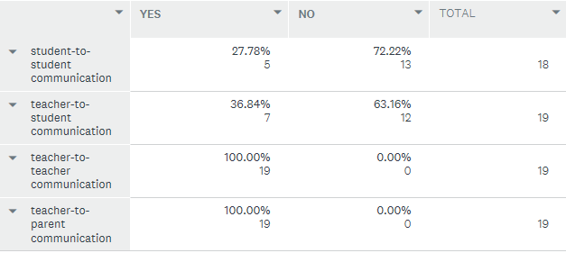
As we look more closely at the digital citizenship at Andrews Elementary it is evident that our staff members feel confident in their receiving equitable access now that we are implementing 1:1 Chromebooks. The staff understands the district’s policies regarding acceptable use and promotes safe, legal and ethical use of technology. The area of concern that we noted was that while teachers are modeling safe, legal and ethical use of technology, not all of our teachers are discussing it with their students which is important for them to do. As a technology plan is developed, it would be beneficial to help ensure that discussions with students are taking place perhaps utilizing modules from “21 Things” from 21things4teacher.net or the YouTube video “Copyright and Fair Use Animation”.

References
21 Things. Retrieved July 5, 2017 from http://www.21things4teachers.net/21-things/

Copyright and Fair Use Animation (September, 2014). Retrieved July 5, 2017 from https://www.youtube.com/watch?v=suMza6Q8J08

ISTE Standards for Administrators. (2017). Retrieved July 4, 2017, from https://www.iste.org/standards/standards/standards-for-administrators

