ISTE NETS-A Standards Paper #3
Standard #3: Excellence in Professional Practice
Alexe Miles and Sharon Thornell
EDIT 760: Instructional Technology Leadership

The ISTE NETS-A Standard 3 primarily deals with the responsibility of educational leaders to promote an environment of professional learning and innovation. Educational leadership and innovation should begin at the top with the administrators. The administrators that promote the use of technology and embrace innovation will empower their teachers to do the same. The administrators create the environment and are responsible for holding the teachers and students accountable for use of technology in their day to day studies. Within the classroom, teachers must be willing to promote an environment of professional learning and innovation as well. Teachers that feel they are supported and that have administrators willing to be innovative are more likely to be eager to implement technology into their daily lessons and to broaden their use of digital resources outside of drill and practice websites.
Alexe Miles and I conducted surveys using SurveyMonkey.com in order to determine the level of excellence in professional practice at Andrews Elementary School. Andrews Elementary School is a large, rural Title I elementary school in Georgetown County. Many of the students that attend this school do not have consistent access to technology outside of the school setting. The limited access that they do have is not regularly used for educational purposes but for entertainment only. Due to this research being conducted during the summer break, only a small portion of the teachers/administrators responded. For this particular survey 24 out of 50 people responded.
Our first question on this survey was asking what types of technology is regularly used by the faculty at Andrews Elementary. The faculty was given a basic list of commonly used educational technology tools as well as the option to list others not given. The results are shown below.

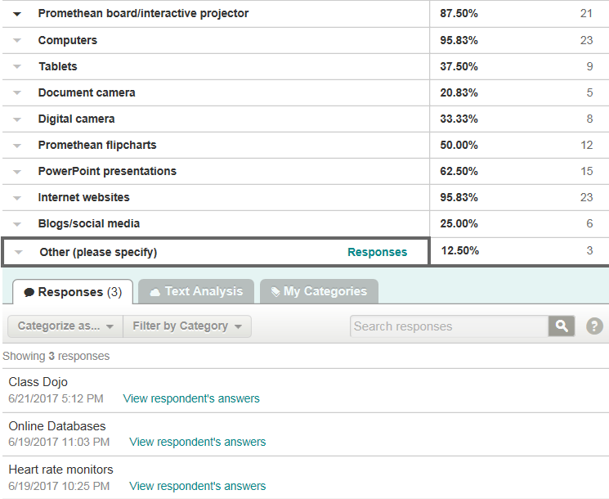
Our second question focused on technology staff development. We asked how often each respondent participated in professional development regarding technology use. One person indicated that they participate at least once a month, five indicated that they participate at least once every 2-4 months, and four indicated at least once every 4-8 months. The majority of respondents indicated that it is once a year or more that they participate, with nine indicating once per year and five indicating that they participate at least once every 1-2 years. This is of medium concern that more teachers are not taking advantage of the many opportunities for technology staff development that is being offered.
Our next question addressed the willingness of our faculty to seek out help from fellow educators who have similar interests and work collaboratively to improve skills. We were pleased to note that none of the respondents indicated that they never seek out help. Four of the respondents indicated that they seek help 1-2 times per year, three indicated 1-2 times per month, six indicated that they seek help more than twice a month but not weekly and the other eleven indicated that they seek help from fellow educators weekly. This was very reassuring that eleven of our colleagues are reaching out for help even though they may not be seeking formal staff development as referenced in our previous question.
We also asked about various forms of technology-based communication systems that are used to remain in contact with colleagues, parents, and community stake-holders. Technology can help maintain contact without increasing the workload of staff. A choice of commonly used methods of communication was given along with the option to list any other forms used. The results are below.
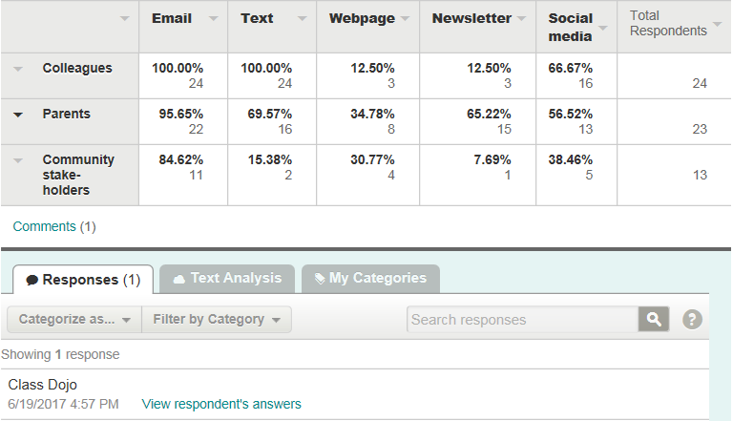
Our next area of focus was on whether staff members would be interested in technology staff development using various technology delivery methods, other than face-to-face, such as webinars, podcasts, videos, and online classes. Research indicates that there are so many options now rather than having to have face-to-face training and it allows staff members to attend as they are able, whether during or outside of work hours. Mark Kassop examines using other methods in “Ten Ways Online Education Matches, or Surpasses, Face-to-Face Learning” (2003). With the busy schedules of teachers, it should be considered in order to optimize staff development attendance. Eleven of the respondents indicated that they would be interested, five indicated that they would not and the other eight indicated that they might be interested. Due to the previous question regarding how often they attend technology staff development, this may be an option to increase the frequency without undue stress to the staff. It warrants further investigation.
Staff was also asked in what areas they felt more technology staff development was desired. Responses were varied, however, the majority requested some facet of training in the incoming Chromebooks, Google Chrome, and Google Classroom. Other topics included further investigation in data driven programs to improve reading and mathematics skills, Read to Succeed recertification, a refresher course in developing Promethean flipcharts including video links, video making and editing, podcasts, and interactive note-booking.
As we looked more closely at excellence in professional practice at Andrews Elementary it is evident that our staff members are utilizing technology on a daily basis. Also that while our school/district offers frequent technology staff development, it is not being taken advantage of as much as it should be. It is reassuring that although the staff is not taking advantage of the formal technology staff development, they are reaching out for help with colleagues. As a technology improvement plan is developed, it would be beneficial to consider alternate forms of technology staff development rather than face-to-face based on respondents’ data.

References
ISTE Standards for Administrators. (2017). Retrieved June 23, 2017, from https://www.iste.org/standards/standards/standards-for-administrators

Kassop, Mark. Ten Ways Online Education Matches, or Surpasses, Face-to-Face Learning. (2003, May/June). Retrieved June 23, 2017 from http://technologysource.org/article/ten_ways_online_education_matches_or_surpasses_facetoface_learning/

The Most Effective Training Techniques (2016). Retrieved June 23, 2017 from http://trainingtoday.blr.com/article/most-effective-training-techniques/

